Experiment / Case Study 5
Experiment Title: To study the functioning of Arrays and Loops in JavaScript.
Software / Tools Required: VS Code, JavaScript, HTML/CSS, Web browser
Experiment Program Code:
CartCalculator.html (HTML/CSS File)
<!DOCTYPE HTML>
<html>
<head>
<meta charset="UTF-8">
<title>Shopping Cart Calculator</title>
<style>
body {
background-color: whitesmoke;
}

.header {
background-color: rgb(233, 204, 39);
box-sizing: border-box;
margin-top: 0px;
align-content:center;
padding: 5px;
text-align: center;
border-radius: 5px;
color: rgb(90, 134, 230);
}

.card {
margin-top: 30px;
background-color: rgb(49, 49, 180);
border-radius: 15px;
padding: 10px 15px;
box-shadow: 0 8px 15px rgba(0, 0, 0, 0.25);
}

input {
border-radius: 8px;
box-shadow: 0 1px 2px rgb(0, 0, 0, 0.1);
}

button {
background-color: rgb(233, 204, 39);
margin-left: 20px;
padding: 10px 15px;
border-radius: 8px;
cursor: pointer;
transition: transform 0.15s ease, background-color 0.15s ease,
}

button:hover {
background-color: rgb(204, 175, 8);
transform: scale(1.05);
}

table {
margin-left: 200px;
width: 75%;
margin-top: 30px;
}

th {
background-color: rgb(233, 204, 39);
color: white;
padding: 10px;
text-align: center;
}

td {
background-color: white;
padding: 10px;
text-align: center;
}

.result {
margin-top: 20px;
font-size: 18px;
}
</style>
</head>
<body>
<div class="header">
<h2>Shopping Cart Calculator</h2>
</div>
<div class="card">
<input type="text" id="name" placeholder="Product Name">
<input type="number" id="price" placeholder="Price">
<input type="number" id="quantity" placeholder="Quantity">
<button onclick = "addToCart();">Add Product</button>

<table id="cartTable">
<tr>
<th>ID</th>
<th>Product</th>
<th>Price</th>
<th>Quantity</th>
<th>Total</th>
</tr>
</table>
</div>

<div class="result" id="result"></div>
<h3>Summary</h3>
<ul id="summary"></ul>
<h3>Expensive Products</h3>
<ul id="expensive"></ul>
<script src="\CartScript.js"></script>
<br><br>
<h3>Designed By: Arunima Das, PRN: 24070521007</h3>
</body>
</html>

CartScript.js (JavaScript File)
let cart = [];

function addToCart() {
let name = document.getElementById("name").value;
let price = parseFloat(document.getElementById("price").value);
let qty = parseInt(document.getElementById('quantity').value);

if(name == "" || isNaN(price) || isNaN(qty)) {
alert('Please enter all fields');
return;
}

let product = {
id:cart.length+1,
name:name,
price:price,
quantity:qty
};

cart.push(product);

displayCart();

document.getElementById('name').value="";
document.getElementById('price').value="";
document.getElementById('quantity').value="";

}

function displayCart() {
let table=document.getElementById('cartTable');

table.innerHTML =
`
<tr>
<th>ID</th>
<th>Product</th>
<th>Price</th>
<th>Quantity</th>
<th>Total</th>
</tr>
`

cart.forEach(function(item) {
table.innerHTML +=
`
<tr>
<td>${item.id}</td>
<td>${item.name}</td>
<td>${item.price}</td>
<td>${item.quantity}</td>
<td>${item.price*item.quantity}</td>
</tr>
`
});

let total = cart.reduce(function(sum, item) {
return sum + (item.price*item.quantity);
}, 0);

let discount = 0;
if(total >= 50000)
discount = total*0.2;

else if(total >= 20000)
discount = total*0.1;

else if(total >= 5000)
discount = total*0.05;

let finalAmount = total - discount;

document.getElementById('result').innerHTML =
`
<b>Total Amount :</b> ₹${total}<br>
<b>Discount :</b> ₹${discount.toFixed(2)}<br>
<b>Final Amount :</b> ₹${finalAmount.toFixed(2)}
`;

let summary = document.getElementById('summary');

summary.innerHTML = "";

cart.map(function(item) {
summary.innerHTML +=
`
<li>${item.name} : ₹${item.price*item.quantity}</li>
`;
});

let expensive = document.getElementById('expensive');

expensive.innerHTML = "";

let exp = cart.filter(function(item) {
return item.price > 1000;
});

exp.forEach(function(item) {
expensive.innerHTML += `<li>${item.name}</li>`;
});
}

Output:
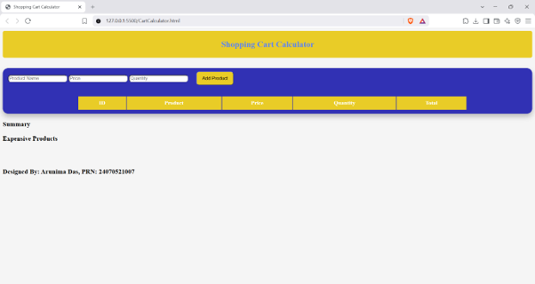
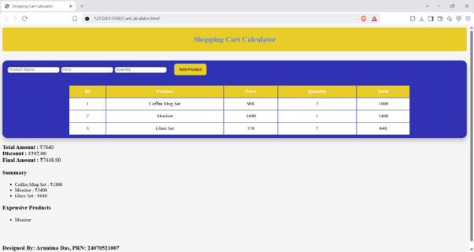

Case Study Title: Create an array of numbers and find the maximum and minimum value.
Case Study Program Code:
ArrayMinMax.html (HTML/CSS File)
<!DOCTYPE HTML>
<html>
<head>
<title>Array Min-Max</title>
<style>
.card {
text-align: center;
background-color: cyan;
border-radius: 15px;
box-shadow: 0 4px 12px rgba(0, 0, 0, 0.12), 0 1px 3px rgba(0, 0, 0, 0.08);
padding: 50px 35px;
transition: box-shadow 0.2s ease;
}

.card:hover {
box-shadow: 0 8px 20px rgba(0, 0, 0, 0.15), 0 2px 4px rgba(0, 0, 0, 0.1);
}

input {
width: max-content;
border: 1px solid rgba(0, 0, 0, 0.15);
border-radius: 5px;
padding: 8px 10px;
font-size: 15px;
outline: none;
transition: border-color 0.15s ease, box-shadow 0.15s ease;
}

input:focus {
border-color: rgb(30, 30, 196);
box-shadow: 0 0 0 3px rgba(30, 30, 196, 0.15);
}

button {
font-size: 16px;
margin-left: 10px;
padding: 8px 18px;
background-color: rgb(30, 30, 196);
color: white;
border: none;
cursor: pointer;
transition: background-color 0.15s ease, transform 0.15s ease, scale 0.15s ease;
border-radius: 8px;
}

button:hover {
background-color: rgb(0, 140, 255);
scale: 1.05;
}

button:active {
scale: 0.98;
}

table {
border-collapse: separate;
border-spacing: 0;
border-radius: 8px;
overflow: hidden;
box-shadow: 0 2px 6px rgba(0, 0, 0, 0.08);
}

th {
background-color: rgb(30, 30, 196);
color: white;
padding: 12px 10px;
font-weight: 600;
letter-spacing: 0.3px;
}

td {
background-color: whitesmoke;
padding: 10px 8px;
transition: background-color 0.15s ease;
}

tr:hover td {
background-color: #e9e9e9;
}
</style>
<script src="MinMaxScript.js"></script>
</head>
<body style="background-color: whitesmoke;">
<h2 style="text-align: center; font-family: 'Franklin Gothic Medium', 'Arial Narrow', Arial, sans-serif;">Student Marks</h2>
<div class="card">
<input type="text" id="name" placeholder="Student Name">
<input type="number" id="val" placeholder="Marks">

<button onclick="addNumber();">Add Student Record</button>

<table id="table">
<tr>
<th>Student</th>
<th>Marks</th>
</tr>
</table>
</div>
<br><br>
<h3>Maximum Marks: </h3>
<div id="max"></div>
<br><br>
<h3>Minimum Marks:</h3>
<div id="min"></div>
<br><br>
<h3>Designed By: Arunima Das, PRN: 24070521007</h3>
</body>
</html>
MinMaxScript.js (JavaScript File)
let array = [];

function addNumber() {
let name = document.getElementById('name').value;
let num = parseInt(document.getElementById('val').value);

const stu = {
name:name,
marks:num
};

array.push(stu);

displayArray();

document.getElementById('val').value = '';
}

function displayArray() {
let table = document.getElementById('table');

table.innerHTML =
`
<tr>
<th>Student</th>
<th>Marks</th>
</tr>
`

array.forEach(function(stu) {
table.innerHTML +=
`
<tr>
<td>${stu.name}</td>
<td>${stu.marks}</td>
</tr>
`
});

console.log(array[0]);

let max = array.reduce(function(max, curr) {
return curr.marks > max ? curr.marks : max;
}, array[0].marks);

let max1 = document.getElementById('max');

max1.innerHTML =
`
<h3>${max}</h3>
`

let min = array.reduce(function(min, curr) {
return curr.marks < min? curr.marks : min;
}, array[0].marks);

let min1 = document.getElementById('min');

min1.innerHTML =
`
<h3>${min}</h3>
`

console.log(min);
}
Output:
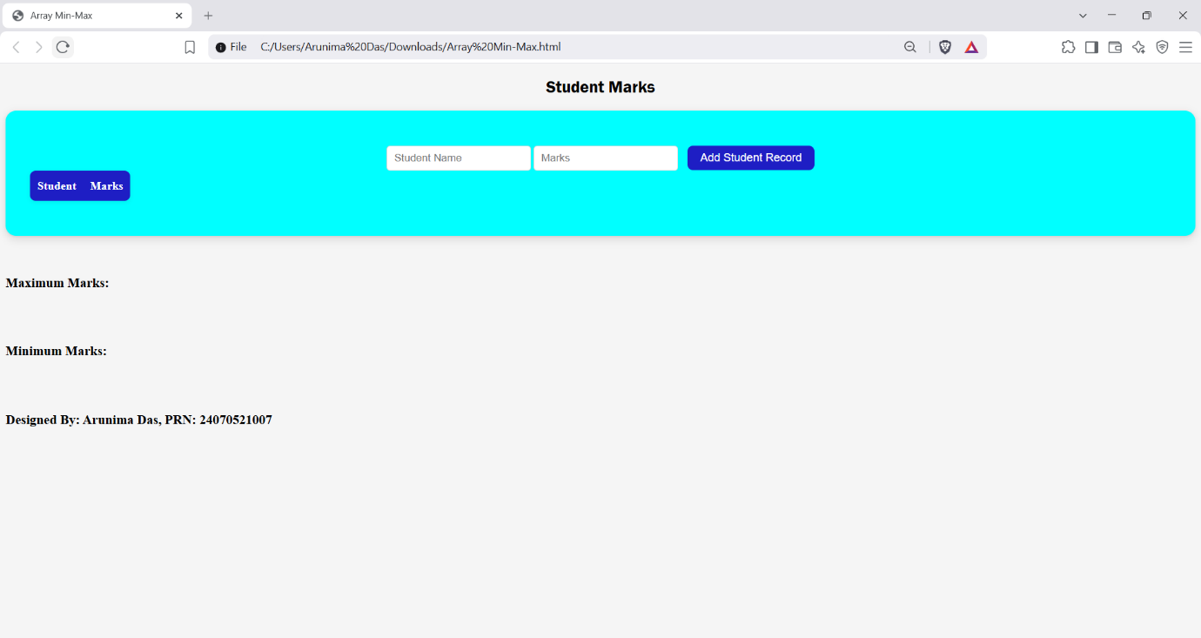
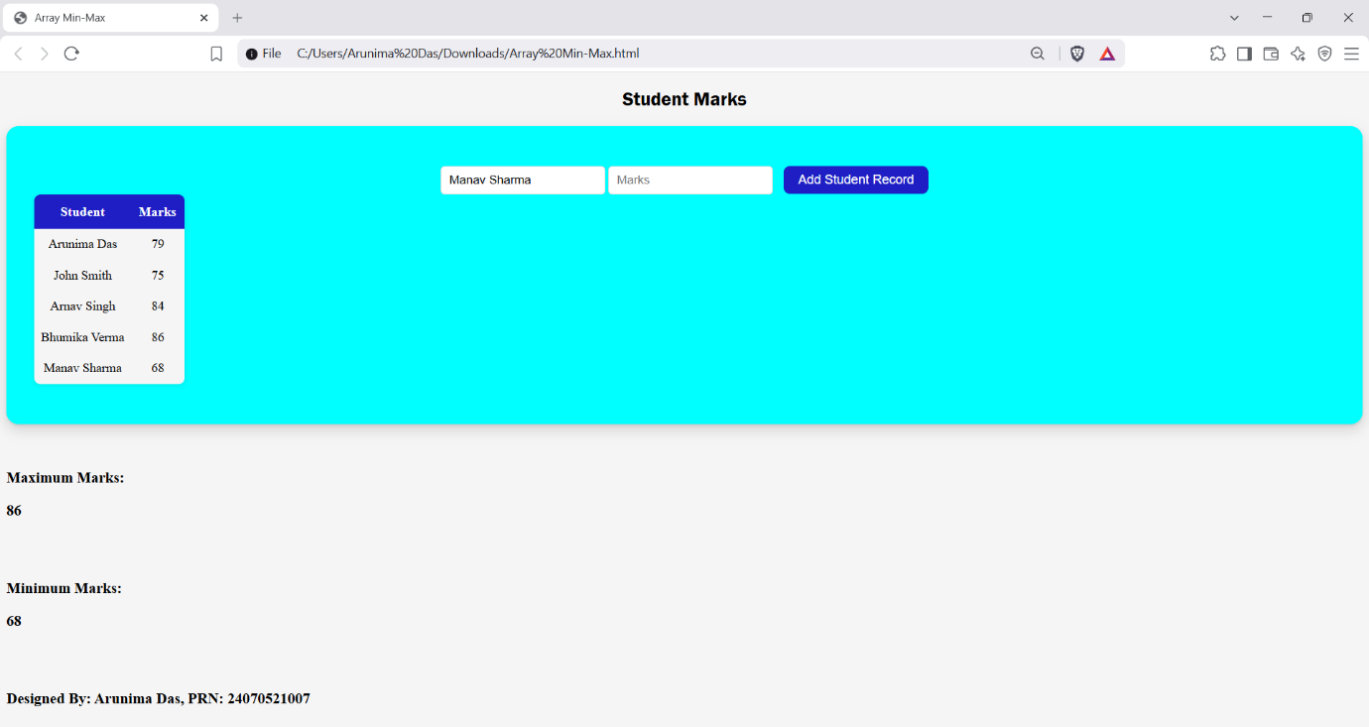
Conclusion: Thus, we can see that arrays are incredibly helpful in managing lists of values or objects. Since arrays in JavaScript can be manipulated easily, we can perform stack functions on it like push() and pop(), manipulate values in it, etc.

